2023-12-22
Stability Measurement

3V3 at no Load:
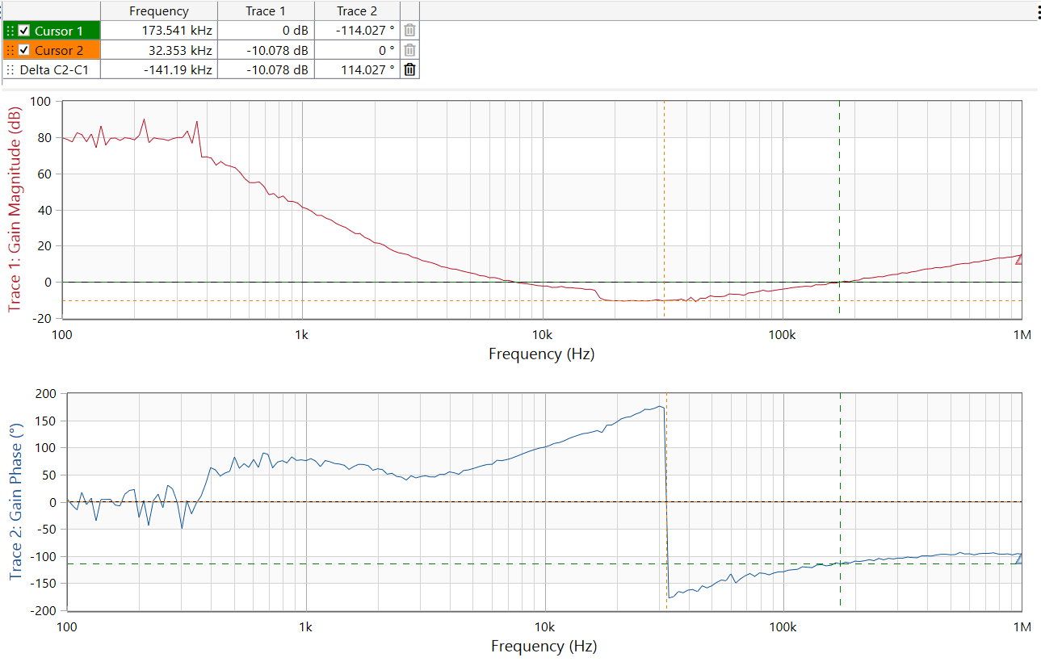

3V3 at Load 100mA:
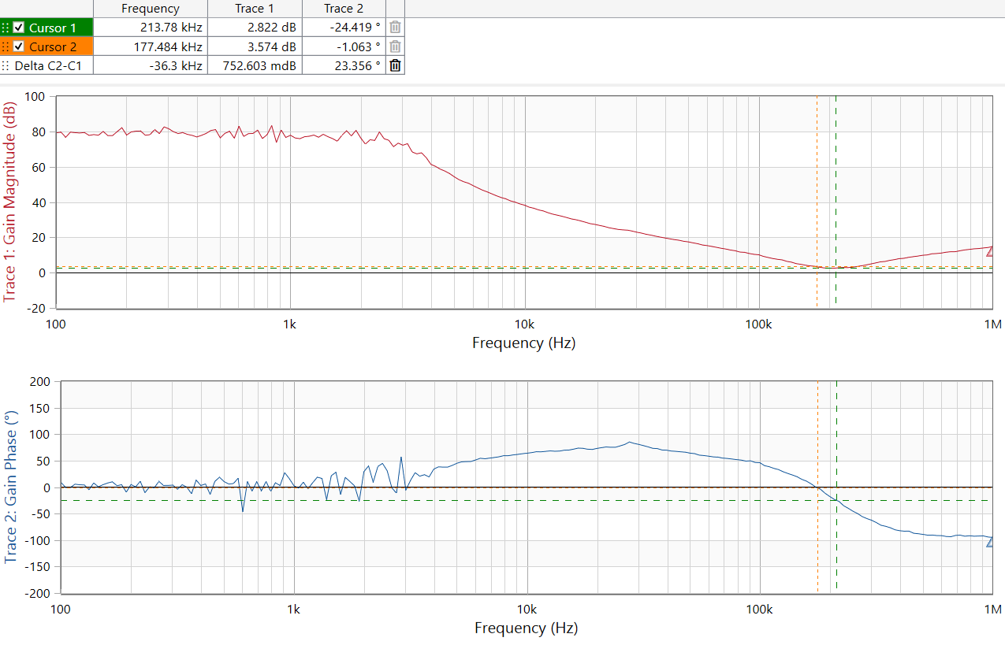
3V3 at 300mA load:
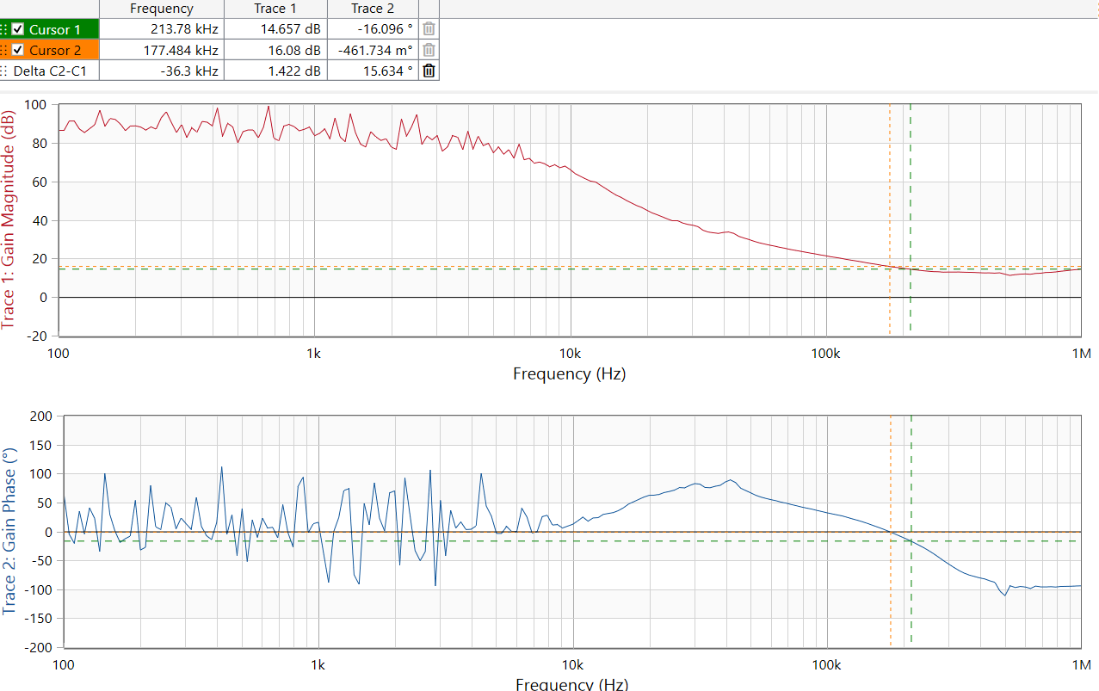

These are totally wrong!
Magnitude does not drop to zero! But rises after 1MHz.
Phase is around zero until 10kHz!

Alternate method: unit step 5mA → 400mA (TTI Load)
3V3, coax probe:
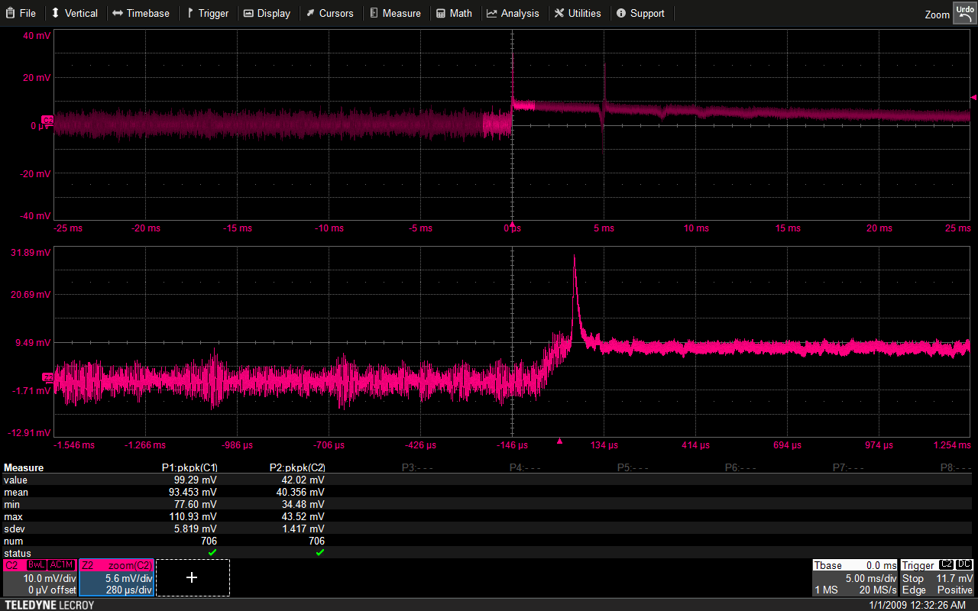

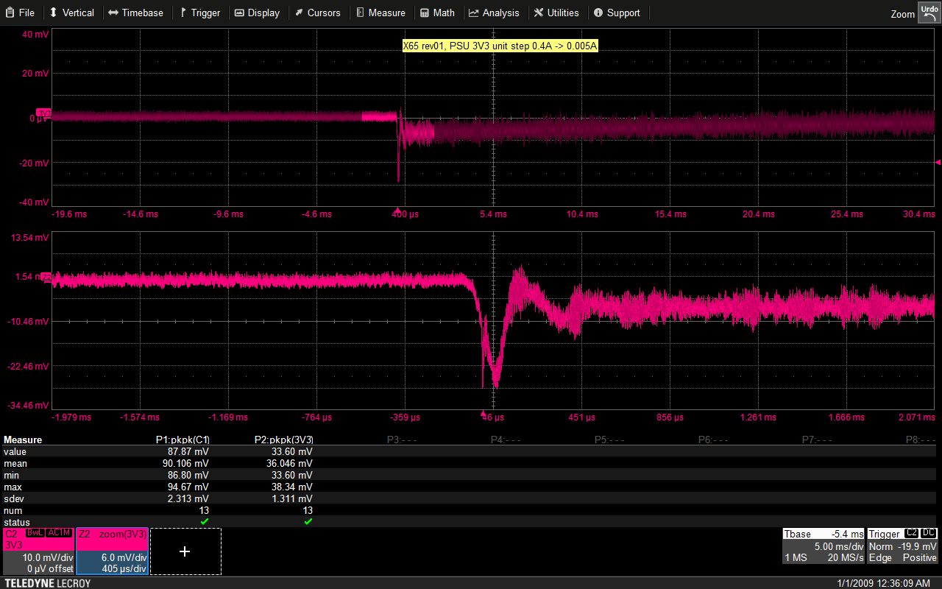

1V2, no load:
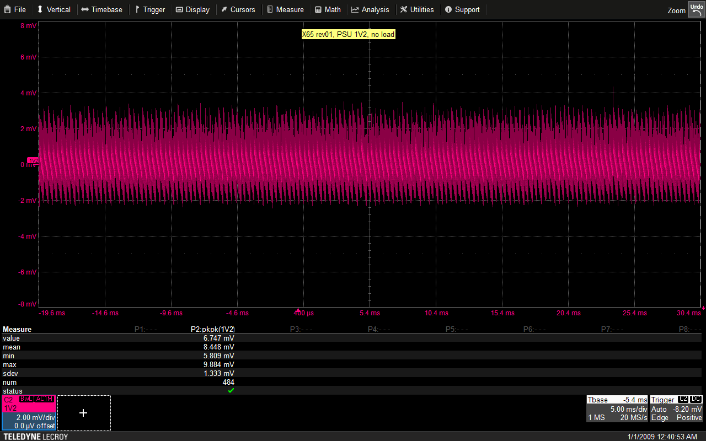

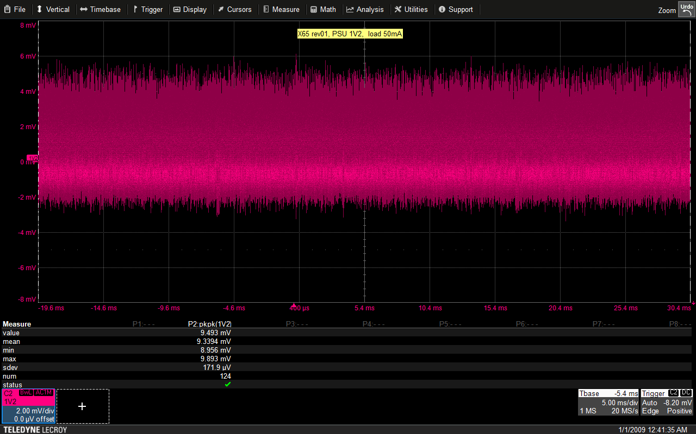

Unit step from 5mA to 50mA at the 1V2:
